SUBSCRIPTION TRACKER WEB APP

Application Requirement
- Authenticate users
- See list of subscriptions
  - CRUD functionality
- See the details of each subscription
  - Price
  - Subscription name
  - Payment date
- Main page is a dashboard for reports (Not Required but would be nice to have)
  - Total Monthly expense
  - Most expensive subscription (bar graph??)
- Be able to pay subscription using the app (WOULD BE NICE TO HAVE)
Key Database Tables
User Table
- id
- First Name
- Last Name
- Username
- Email
- Password
Subscription Table
- id
- Title
- Price
- Due_date
- categoryID
Category Table
- id
- category_name
Payments_History Table
- id
- price
- payment_date
- subscription_id
- user_id
ERD
https://lucid.app/lucidchart/invitations/accept/inv_e1496194-e945-40a7-8602-44d34f27fcc2?viewport_loc=-19%2C-8%2C1365%2C1033%2C0_0
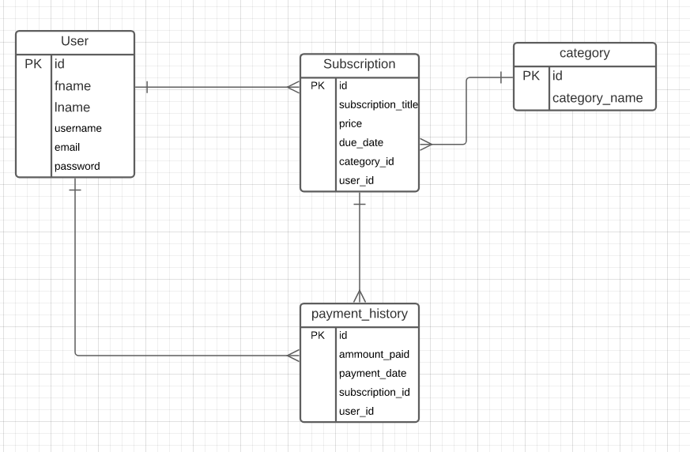

TECHNOLOGIES
Back end
- NodeJS
- Express
- Sequelize
Database
- MySQL
- AWS EC2 Instance
Front end
- NodeJS
- Axios
- Bootstrap

